Wk11 - Code Review
Why code review?
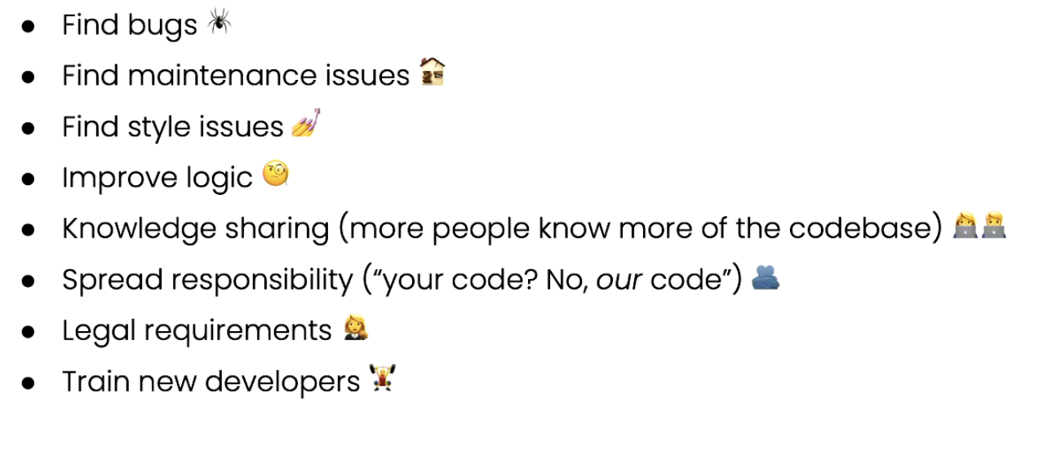

Pull/merge requests
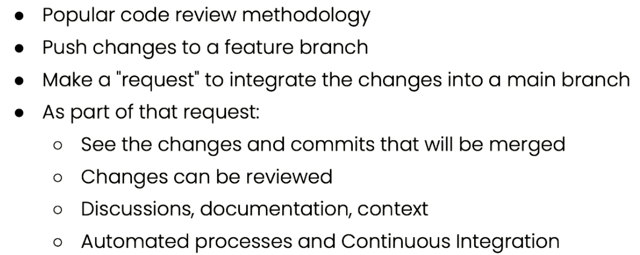

Pair programming
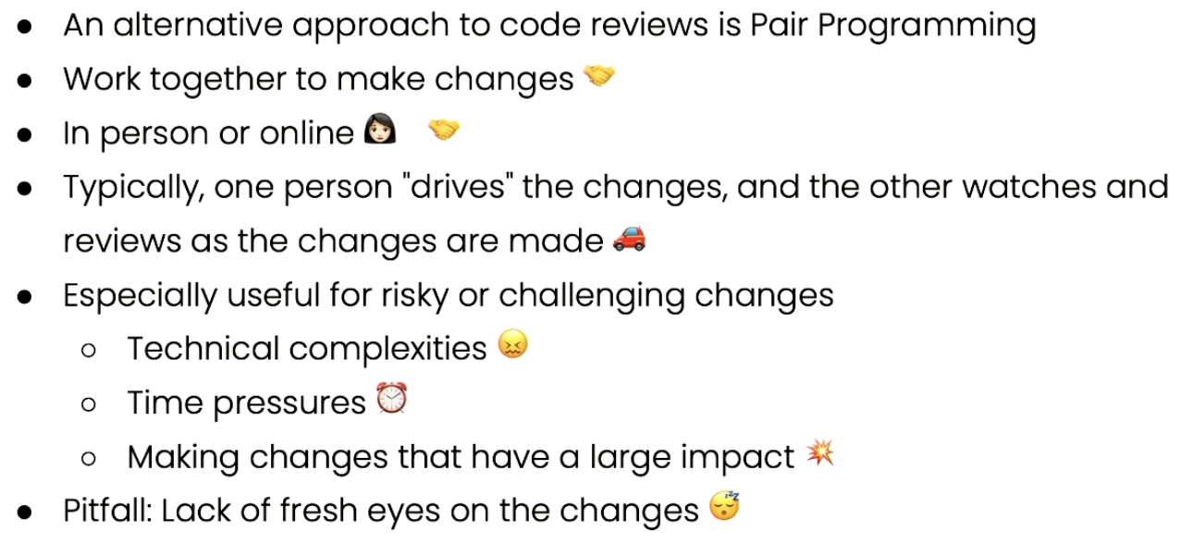

Requesting a code review
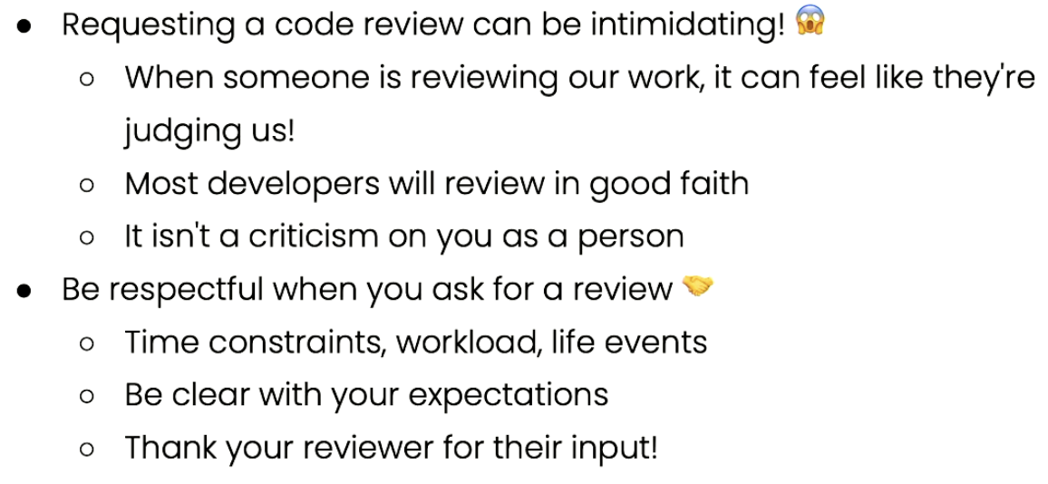
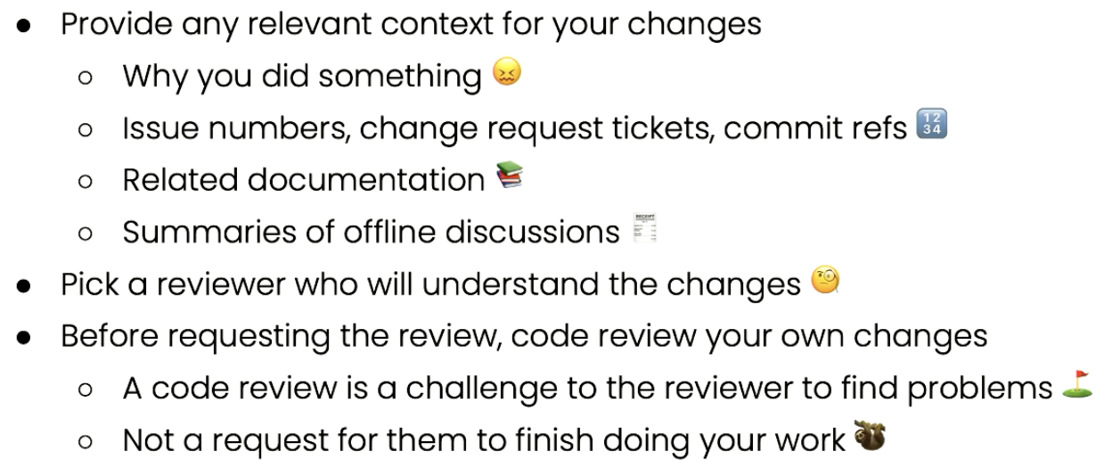

Being a good reviewer
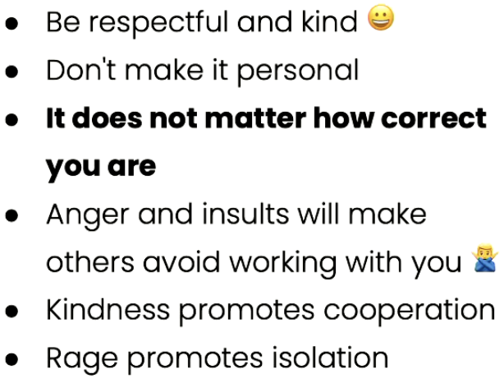
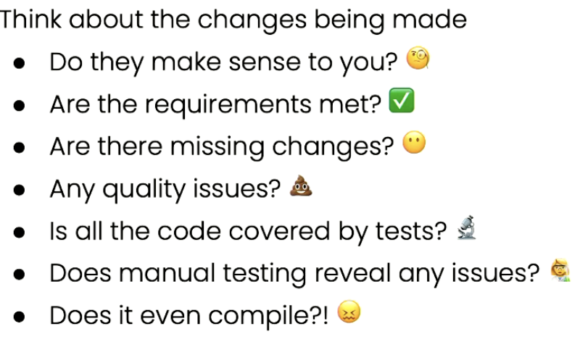
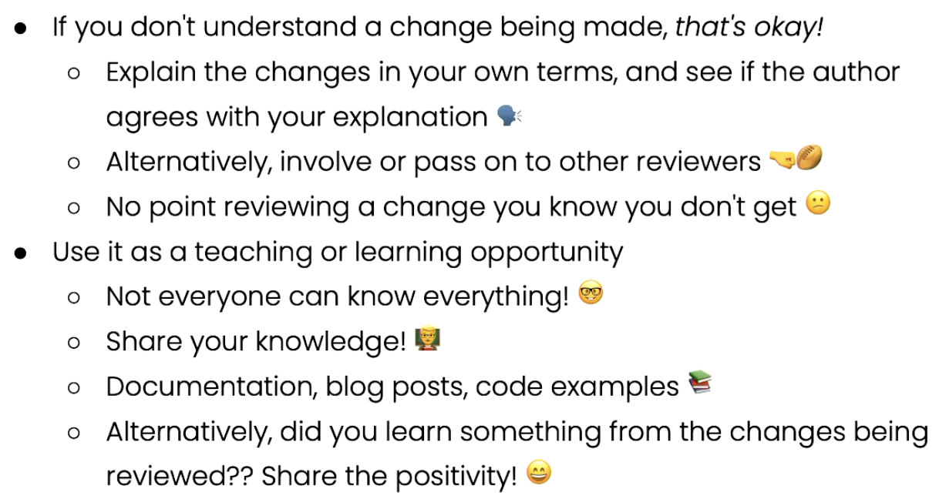

Challenges of code review
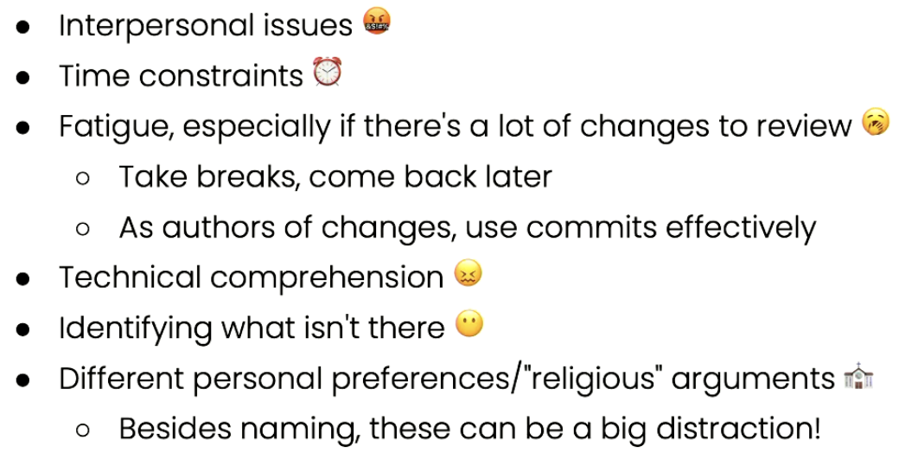
Tools for code review
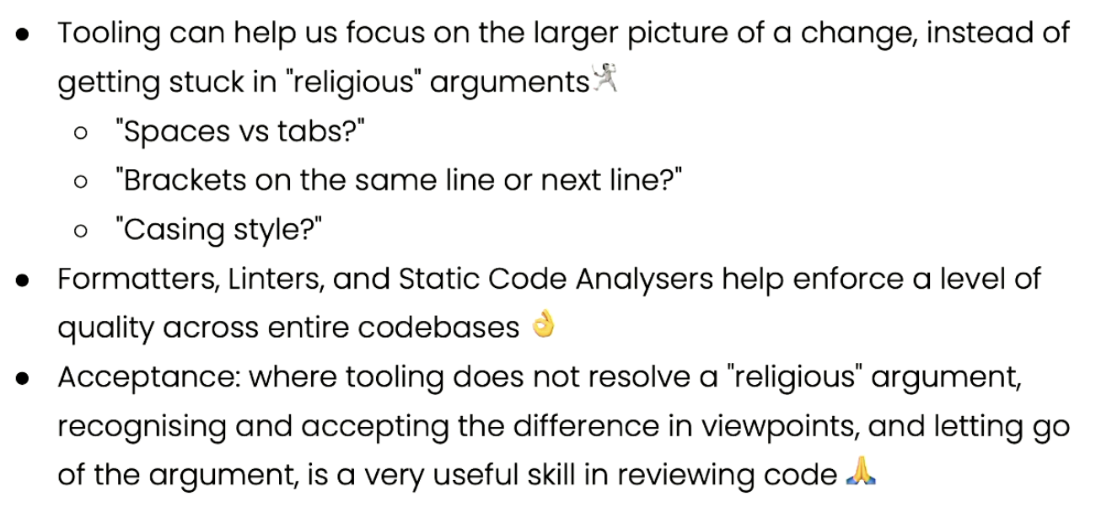
- Linters
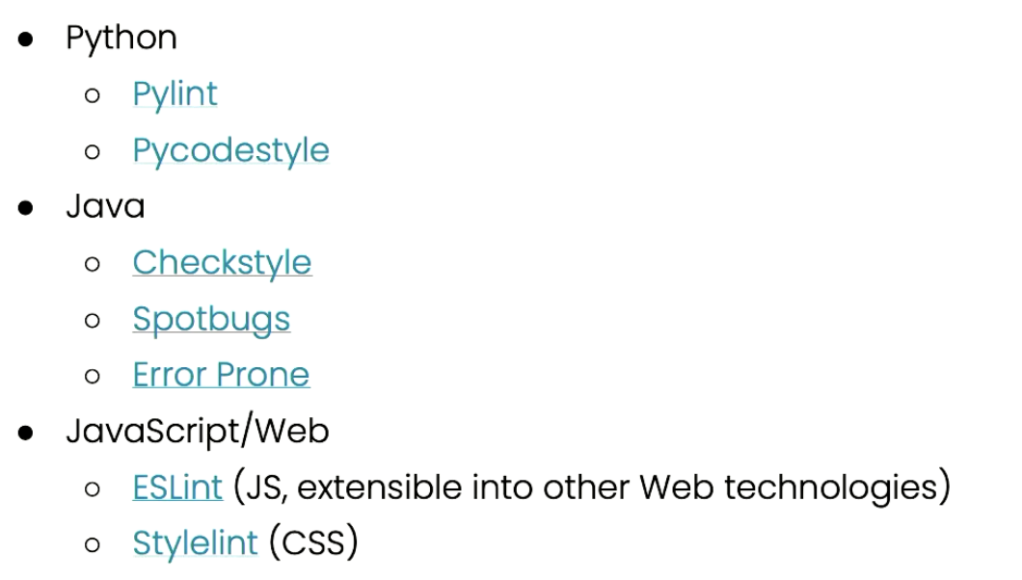
- Formatters like linters, but actually make the change
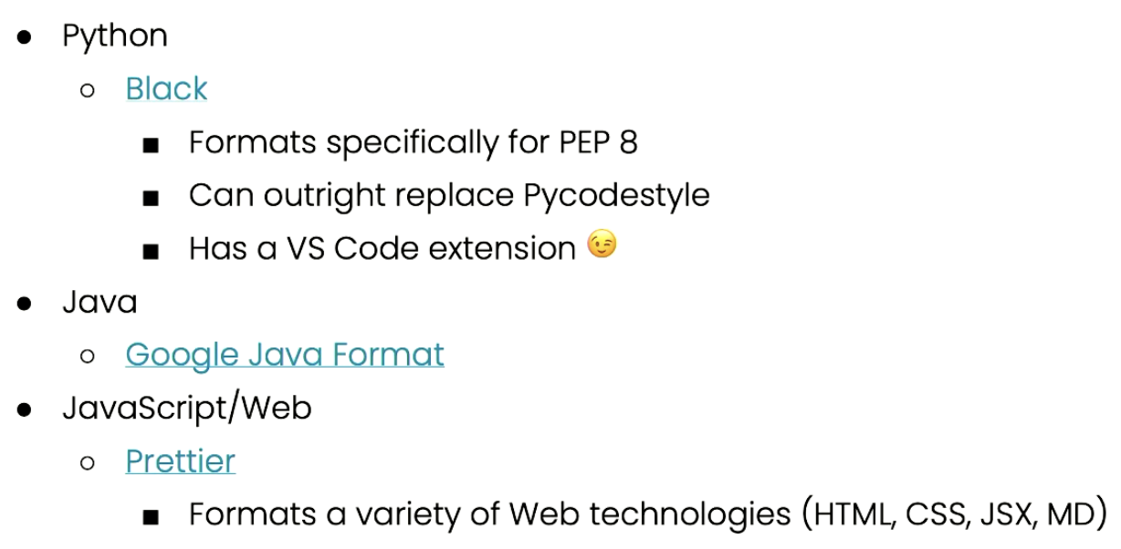
- Static Code Analysers
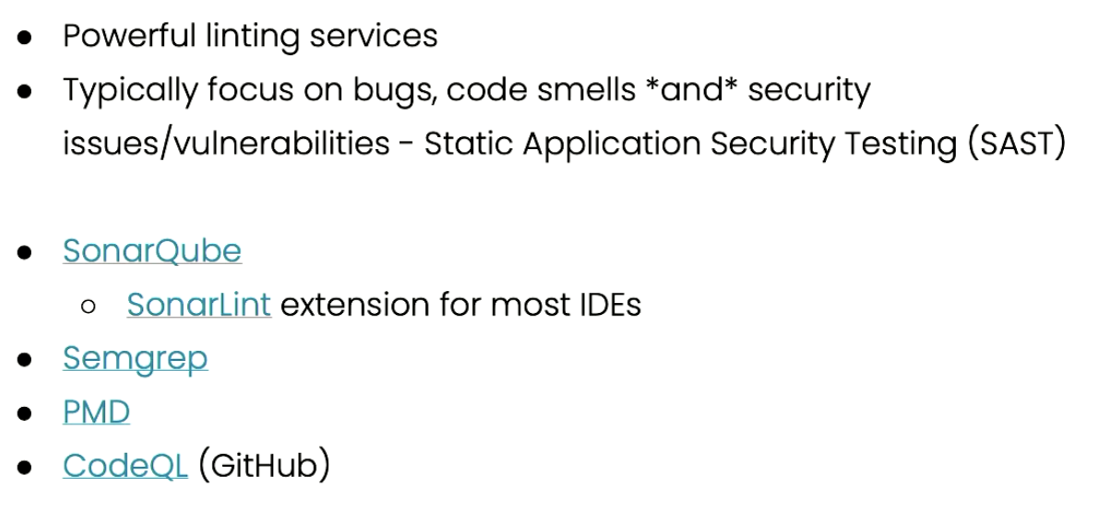
- Continuous integration

General tips
- Apply/adopt skills (code reviewing, unit testing) learnt from units into small projects NOW
  - Gives you a scaffold to work with in the future, even for industry, making programming more efficient
  - Maintain best quality of code (use linting, do documentation)
- Resolving merge conflicts
  - Software: beyond compare
  - Having 2 pieces of code side by side and then the result at the bottom is most helpful view
- Master the tools of git!

